PG-DBDA

Linux and Cloud Computing

Shell

1.Write a shell script to find the largest number among three numbers entered by the user

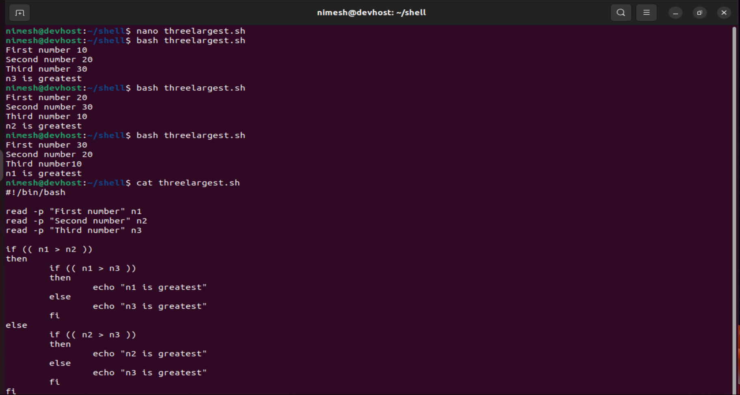

2.write a shell script to display a menu like “1.Date , 2.Cal 3.Ls, 4. Pwd, 5.Exit” and execute commands depending on user choice.

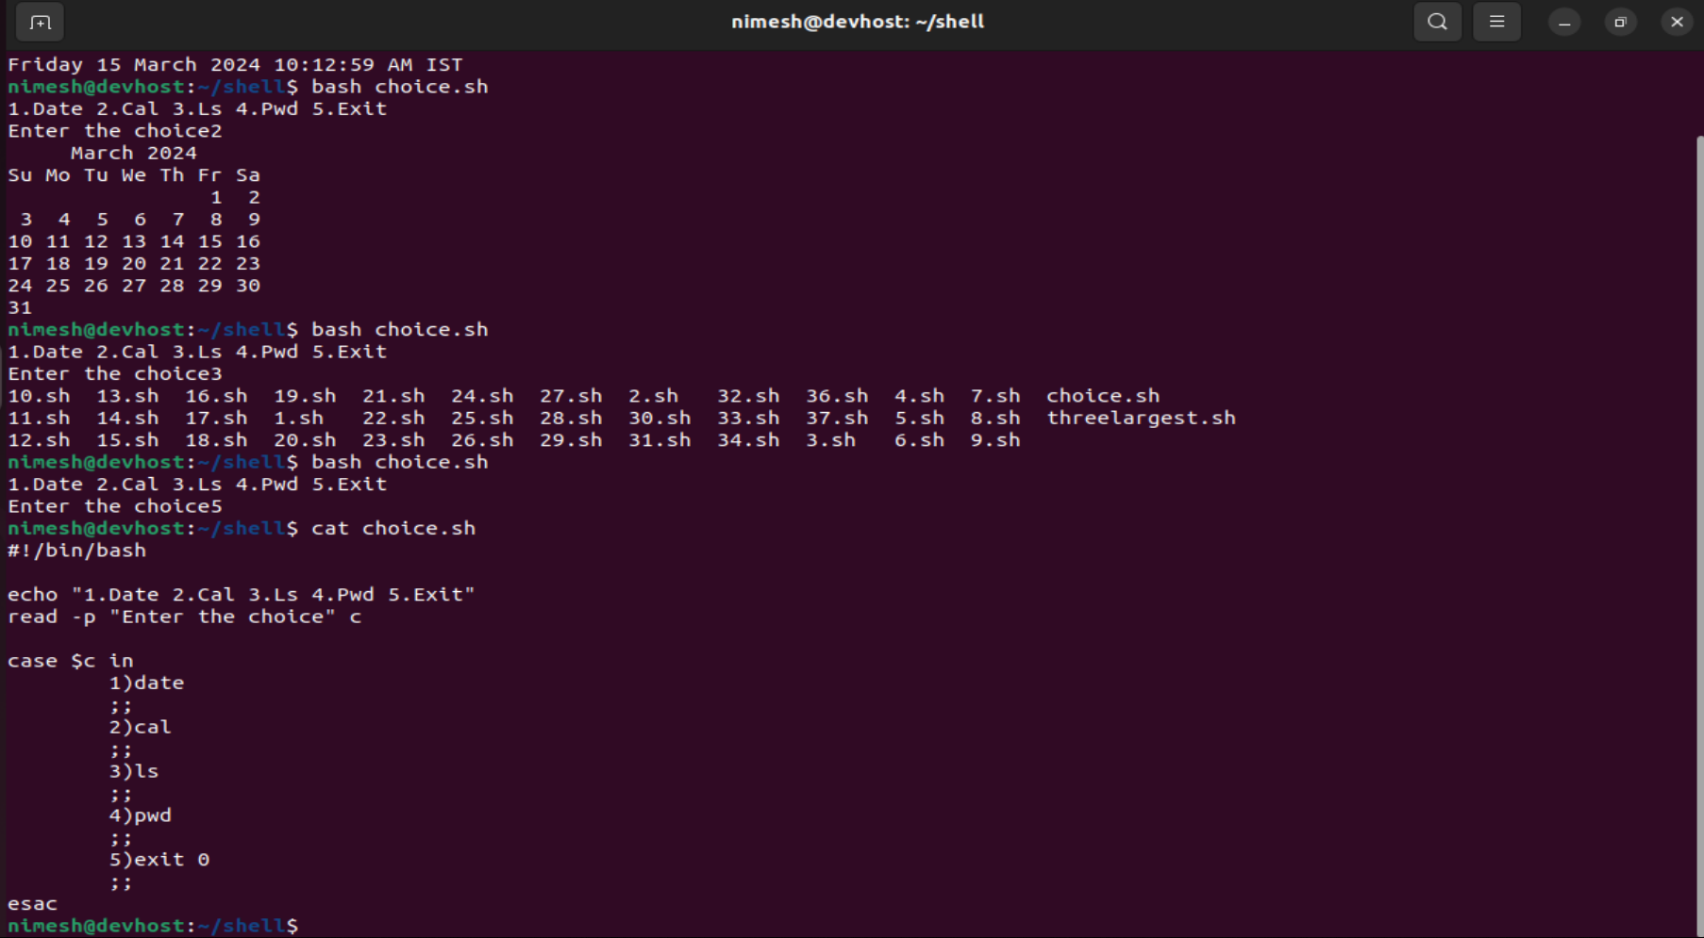

3.write a linux Directory and File management script that allows the user to perform the following actions

**Create a new directory with the specified name**

**Rename an existing directory with the new name**

**Move an existing directory to the new location**

**Delete an existing directory**

**Create a new file in specified directory with a specified name and give read write permissions to user and group**

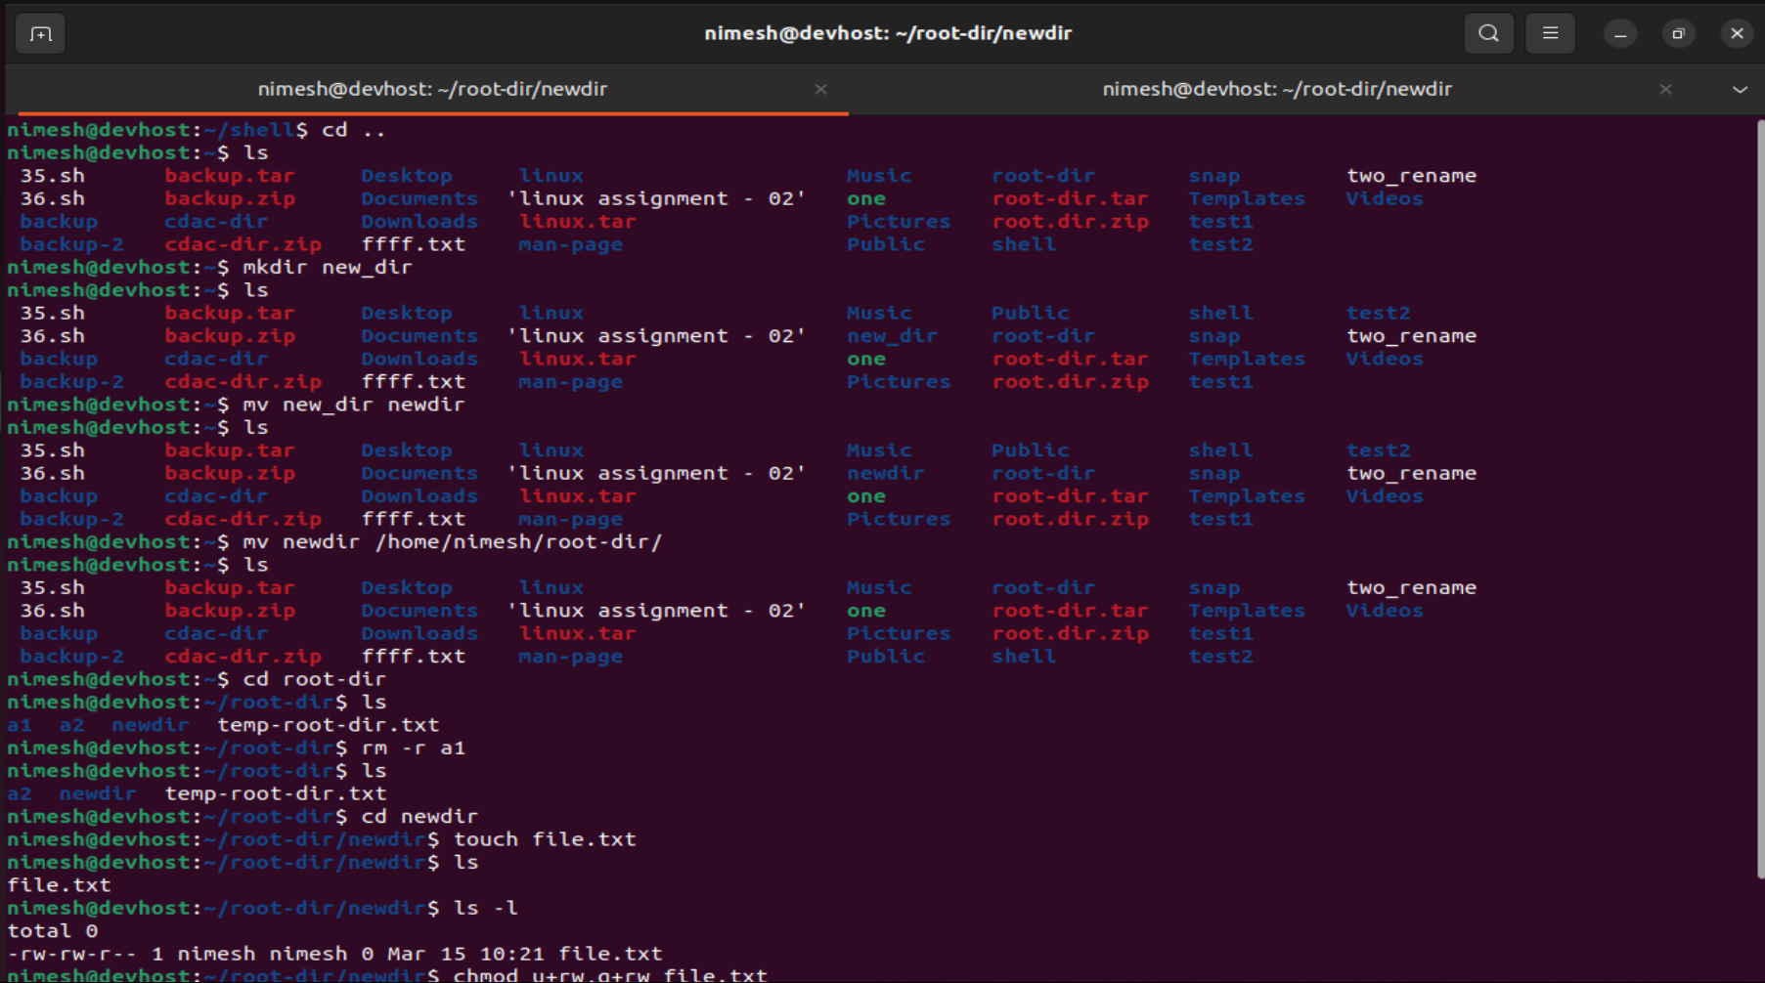

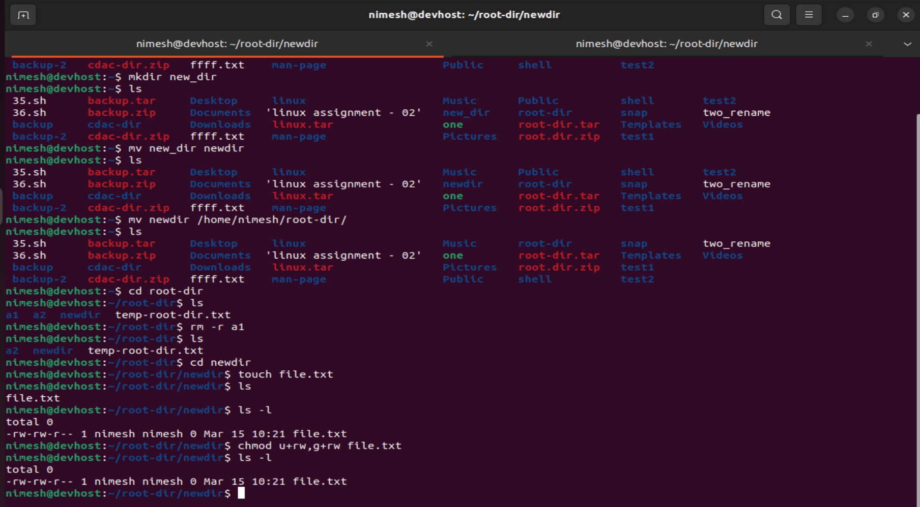

Cloud

Create a Linux EC2 and access the EC2 through putty on your system. Convert this .pem file to .ppk file and then create a html page and make it available on the public IP address

1. Go to AWS Console and search for EC2.

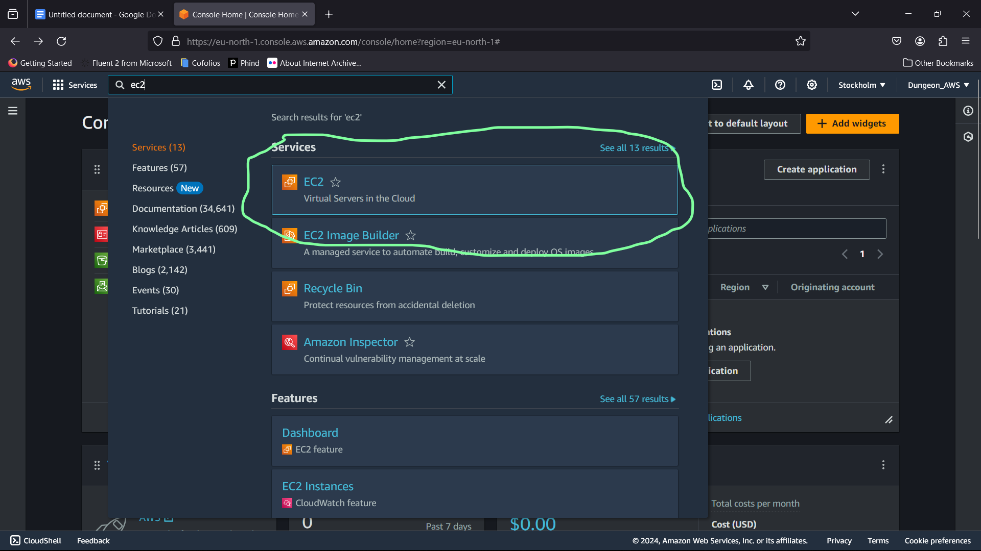

1. Create/Launch a new instance by clicking on the launch instance

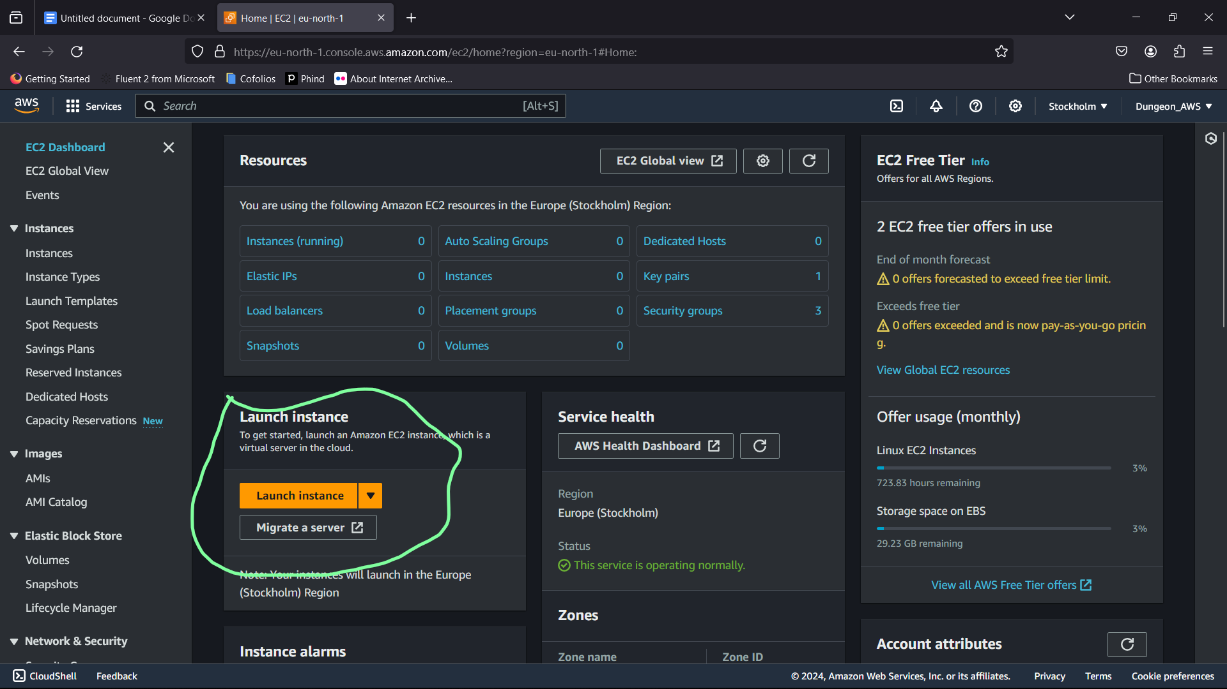

3.Give the instance a name like i have named it - ‘myinstance’

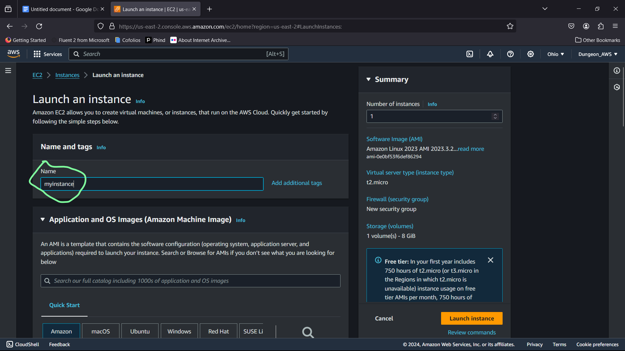

4. Create a key pair with the help below image

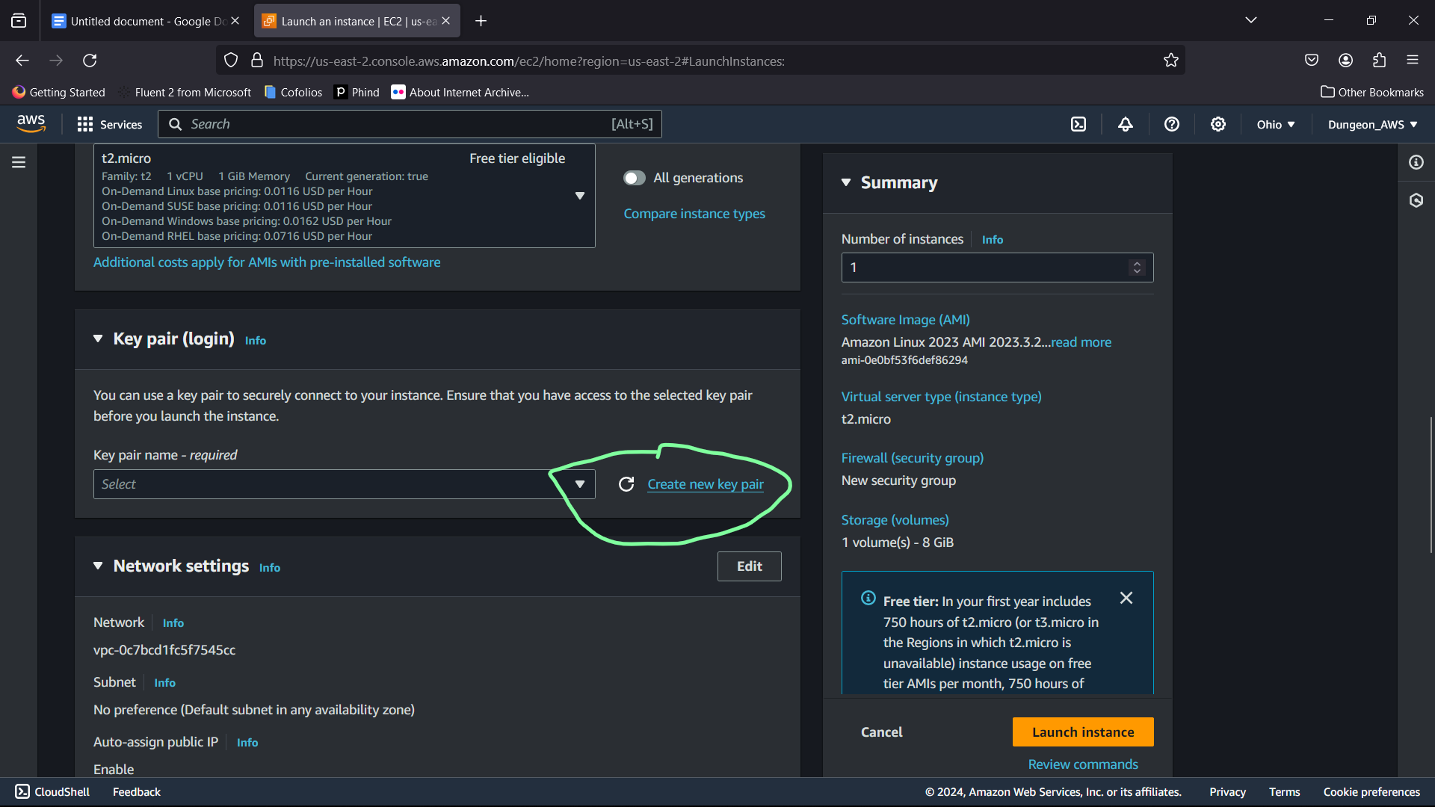

5.Give the name to the key name pair. Set it to .ppk file format and then click on create a key pair.

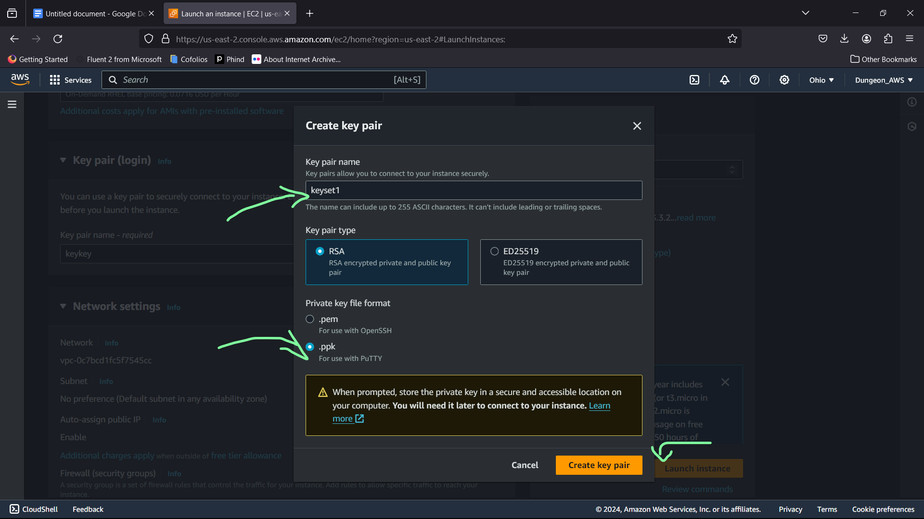

6. Click on below written ticks near the checkbox and then launch instance situated on the right end of the screen.

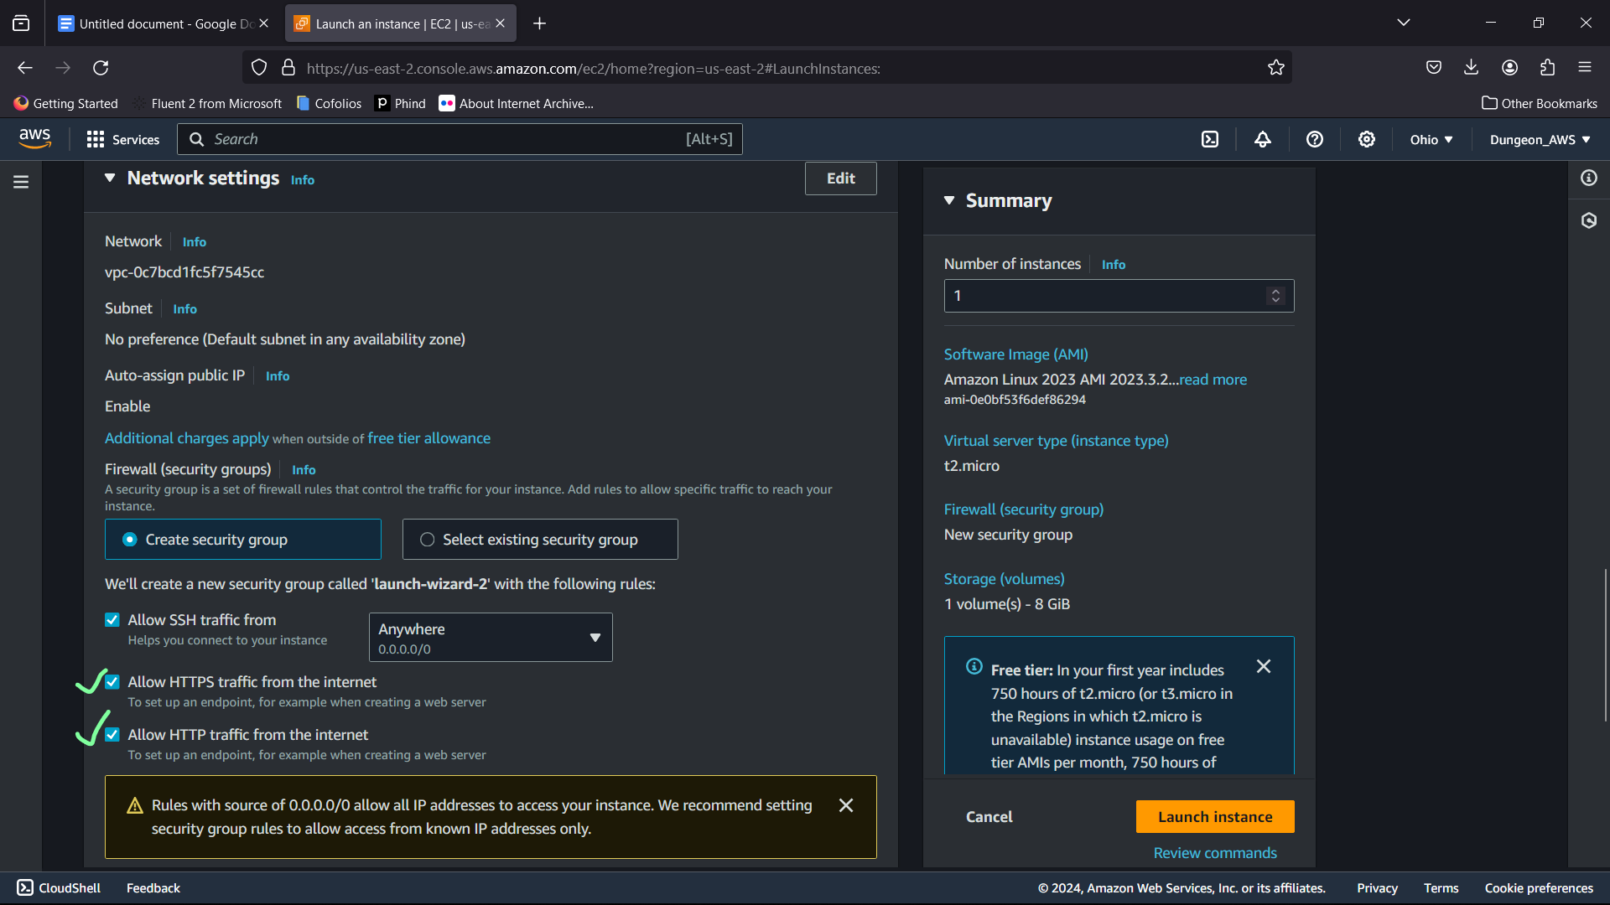

7.Hence you will be successful of creating the instance

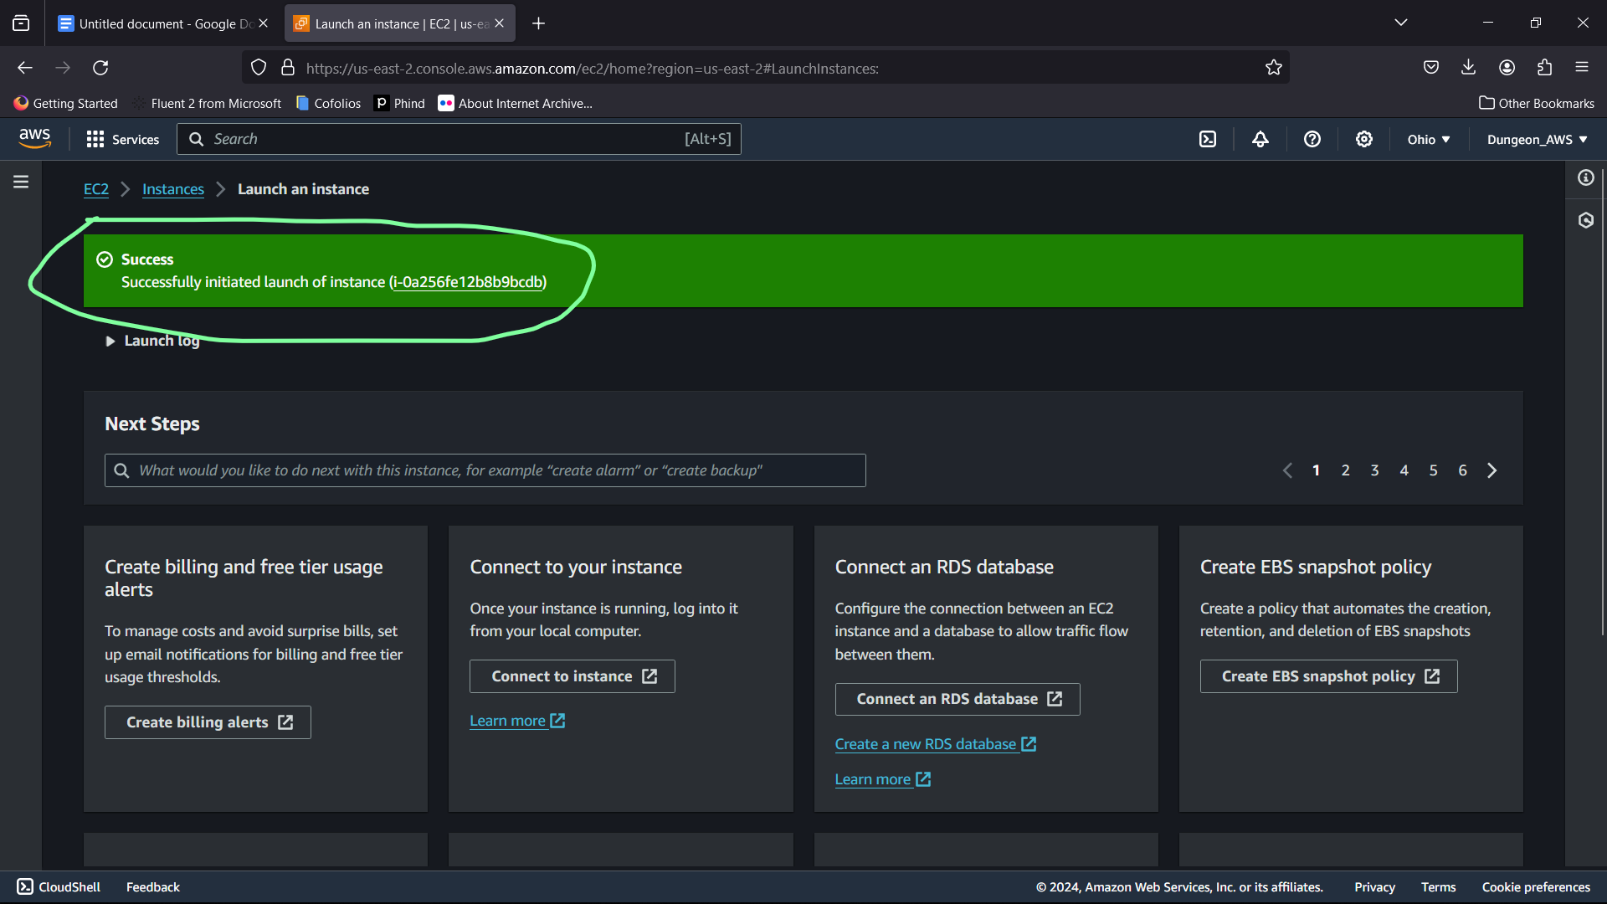

8. Select the instance and then copy on Public ipv4 address.

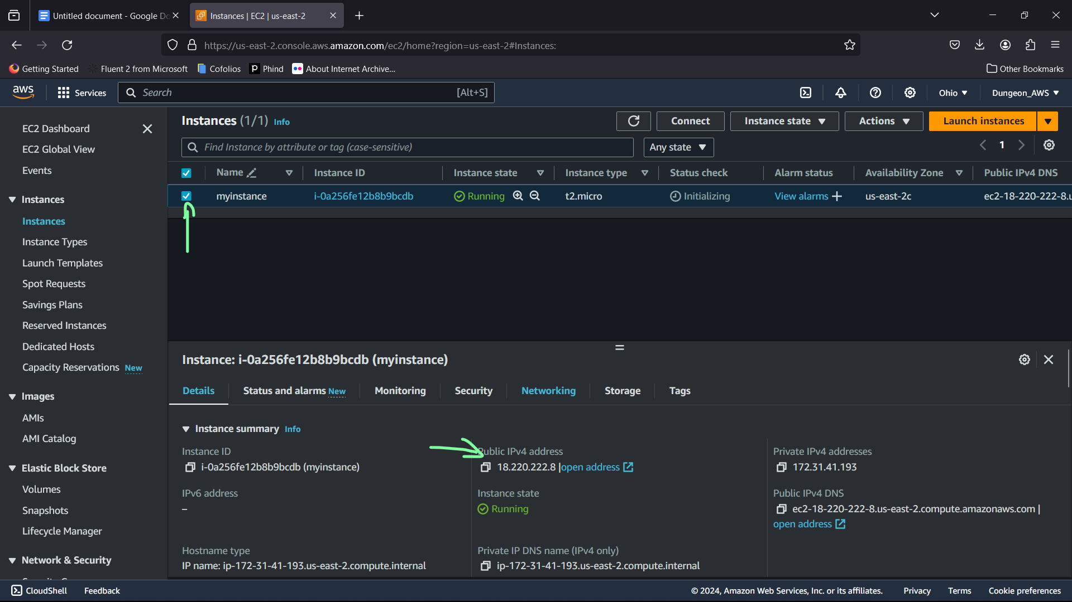

9.Open Putty

Add the hostname based on the below like ‘ec2-user@<<IPv4 add>>

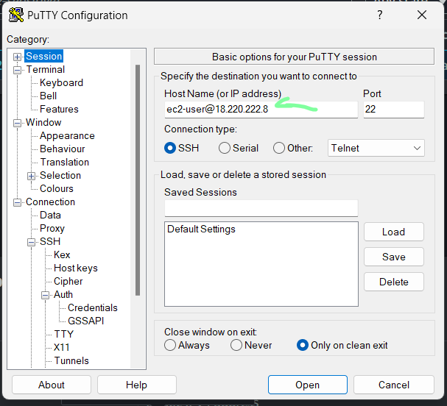

10.Then go to the SSH in Category section and then go to the SSH and then to the Credentials. And then put the key inside the private key file for authentication using browse and getting the key pair which we got before.Then Click Open.

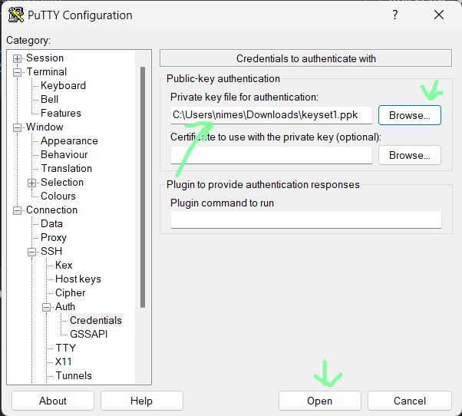

11. Click on Accept.

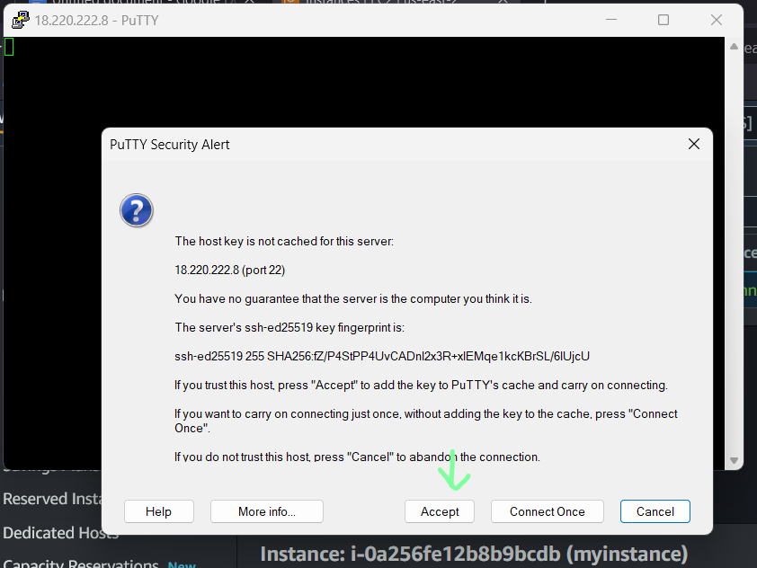

12. Open it looks like this. Go for commands

Sudo -i for root user and then

Yum update -y -> update the existing packages

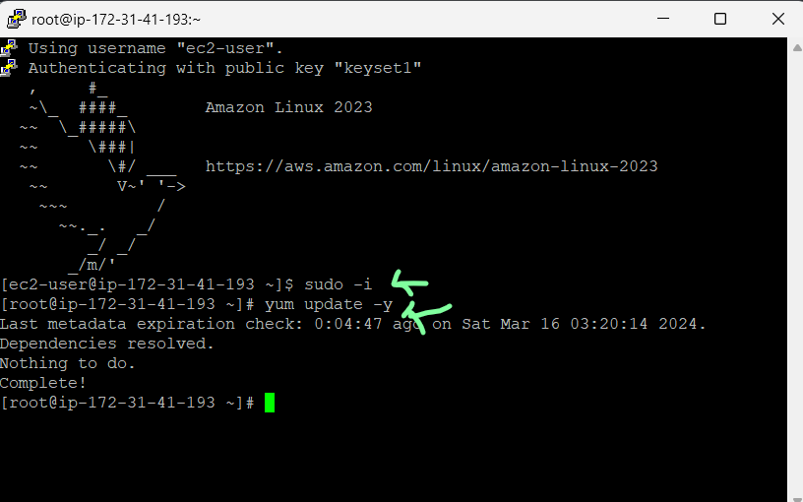

Yum install -y -> install the package based on the installation

Yum install httpd -y -> install the httpd package manager.

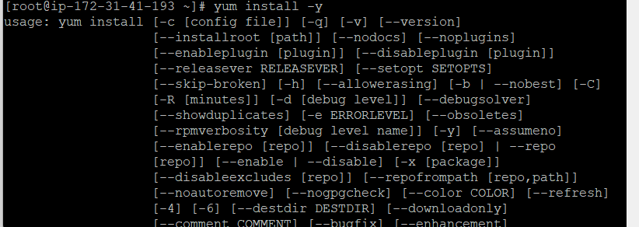

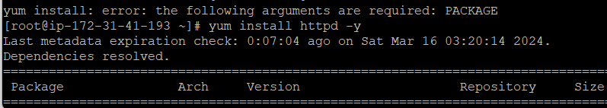

Systemctl start httpd -> initiate the httpd server

Systemctl status httpd -> check the status

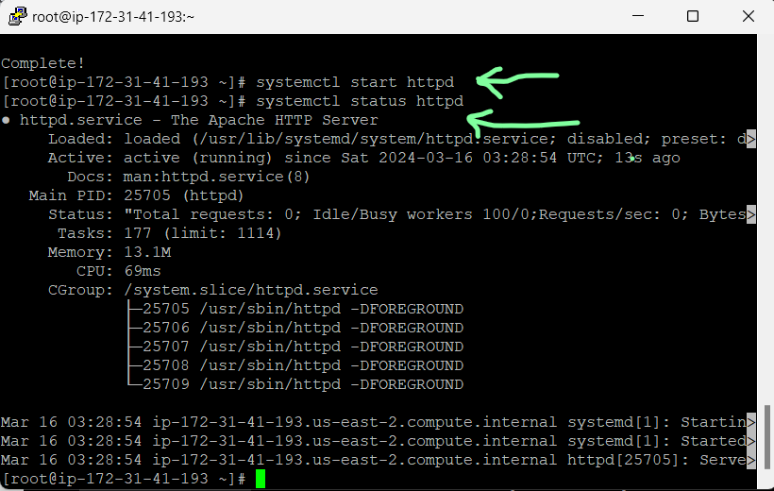

Systemctl enable httpd -> it enables the httpd server .

Cd /var/www/html -> for html folder

Vi index.html -> for text editor

Cat index,html -> to show the contents inside the file

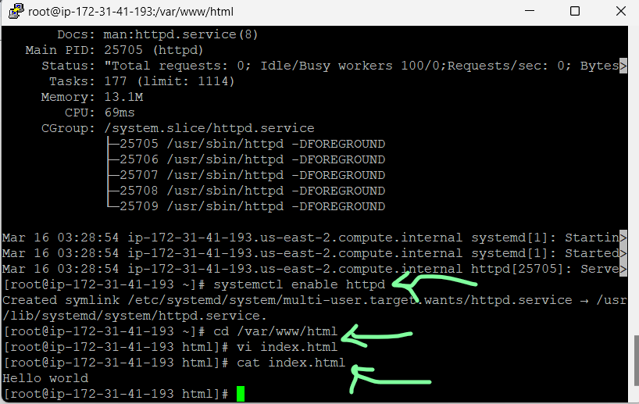

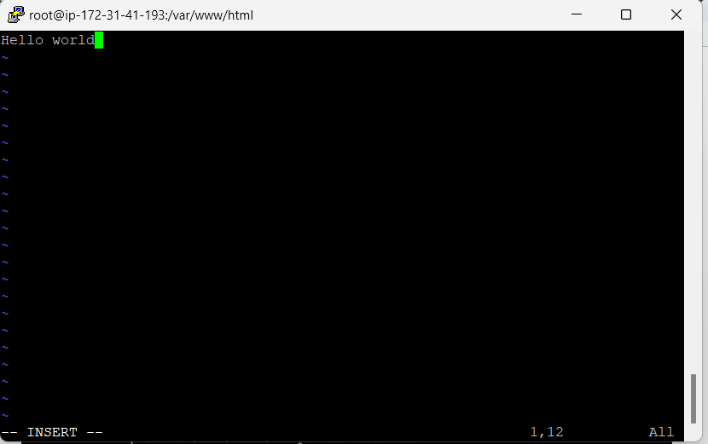

This is the desired output of making a html page and make it available to the public Ipv4 address.

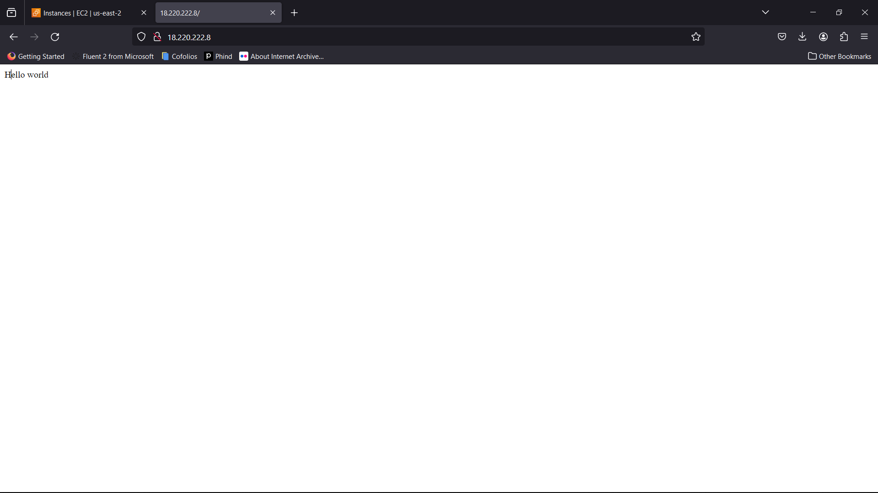

—----------------------------------------------------------------------------------------------------------------

Cloud Question 2

S3 ->

1.Open AWS console and then search for S3 until you see this.Click on S3

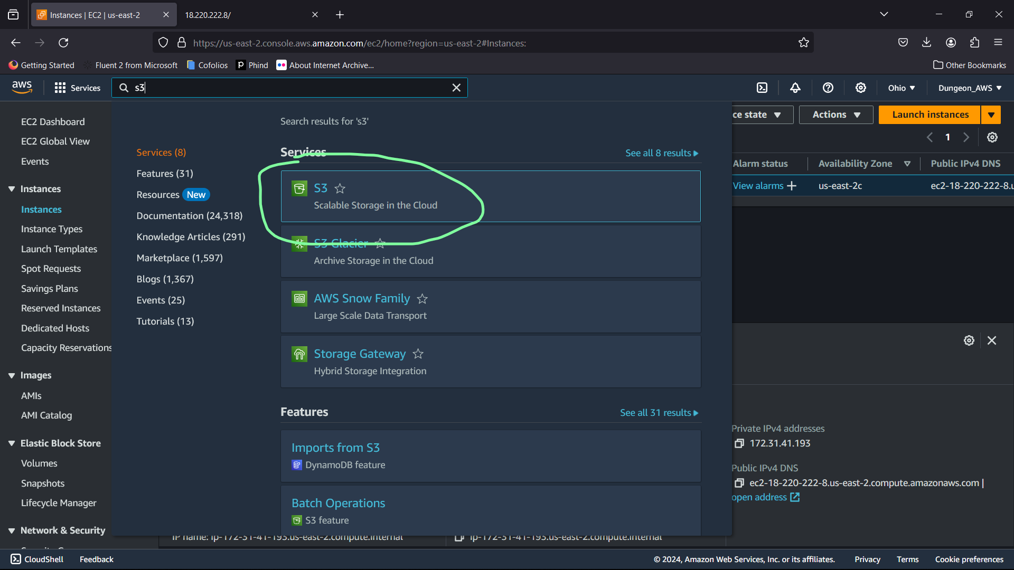

2. Click on create a bucket.

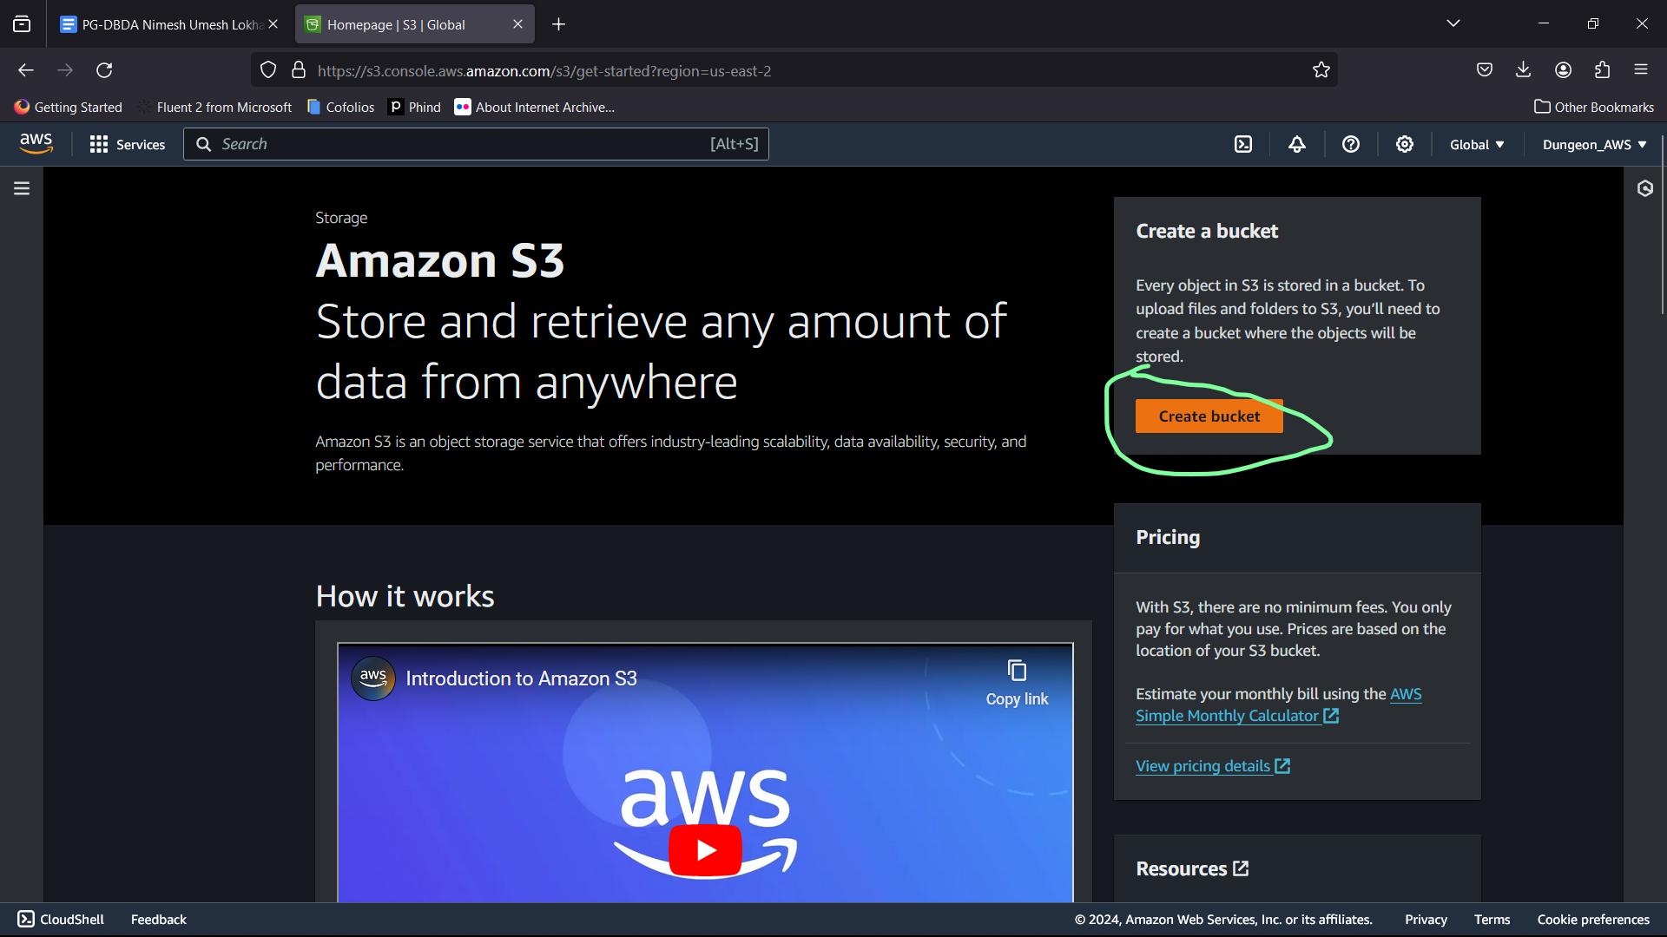

3.Click on adding new bucket and ACL enabled

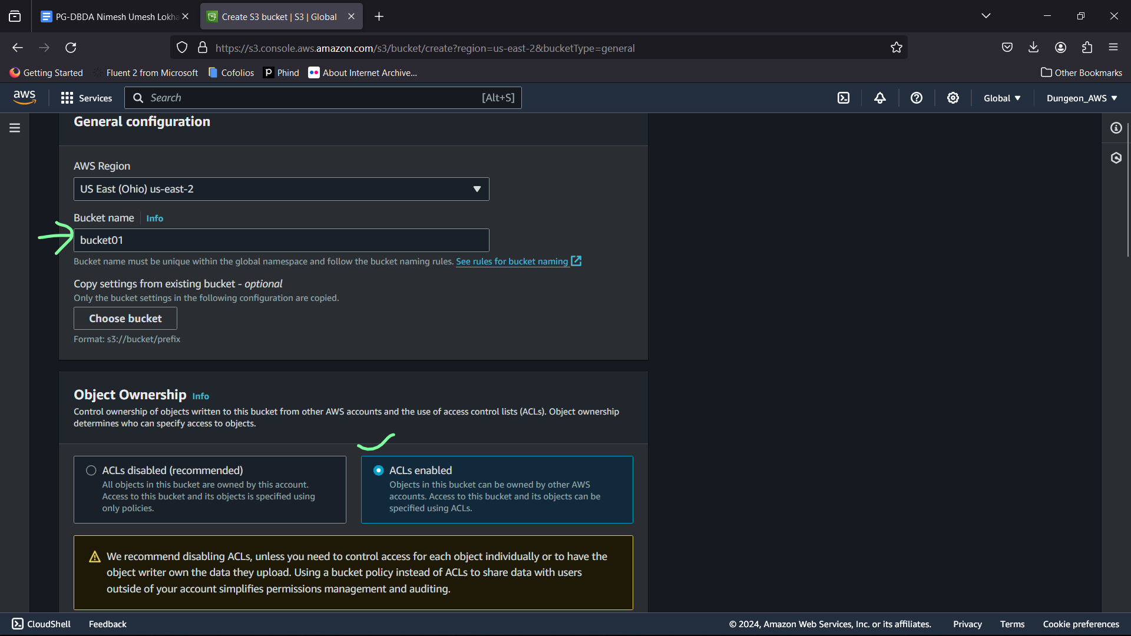

4.Click off to the checkbox in block all public access and then click on the checkbox below having the warning block.

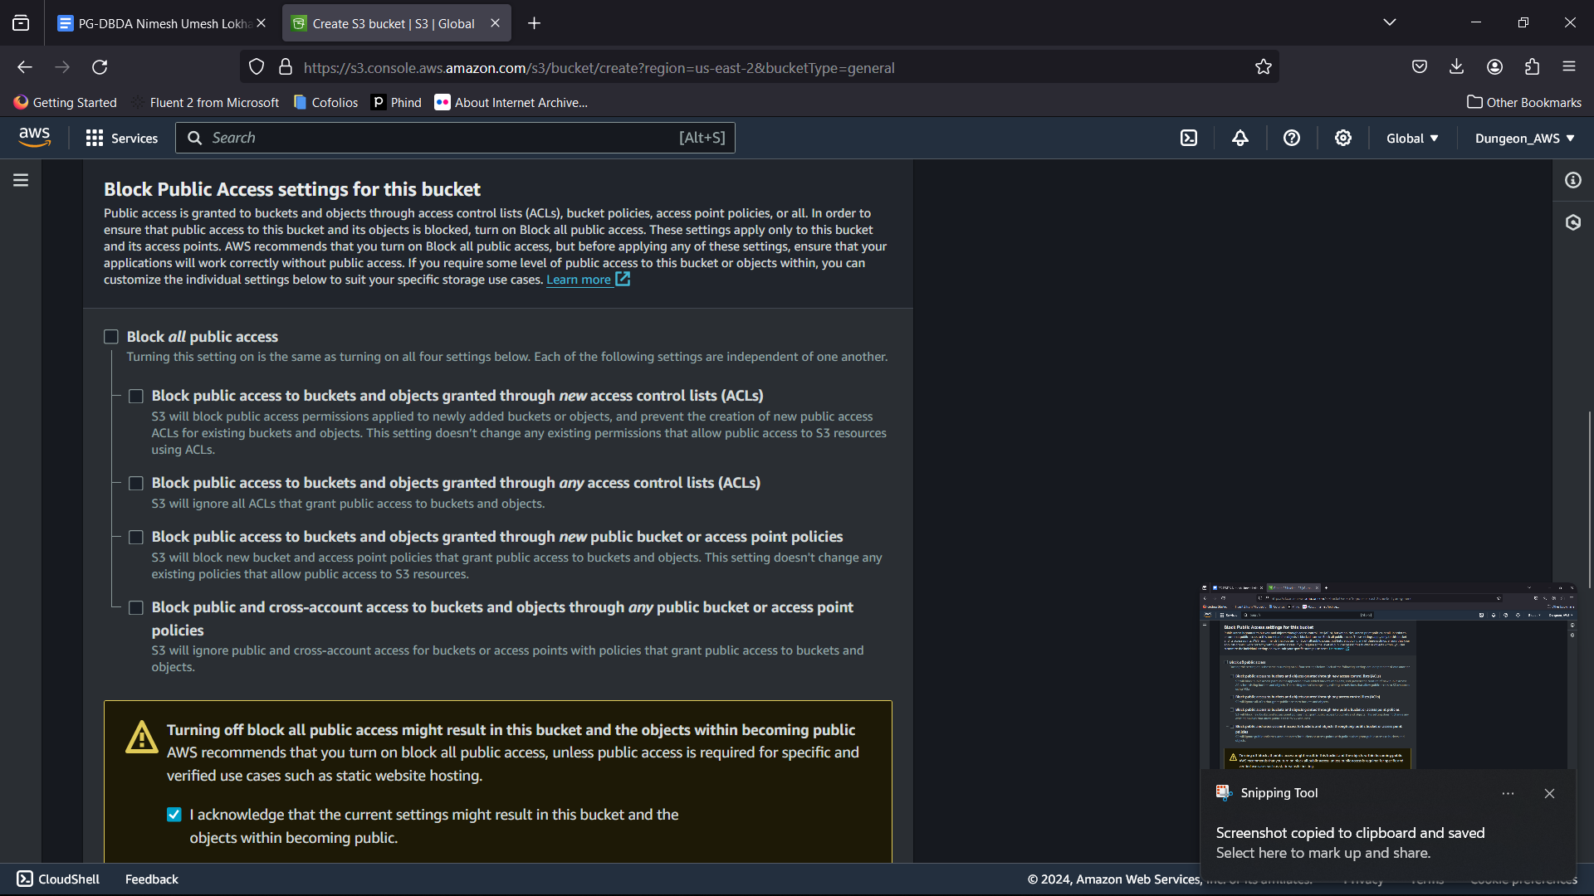

5.Click on disable in Bucket key below (in image)

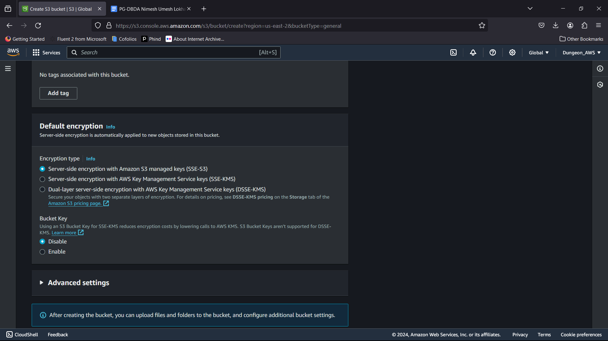

6.Click on create bucket.

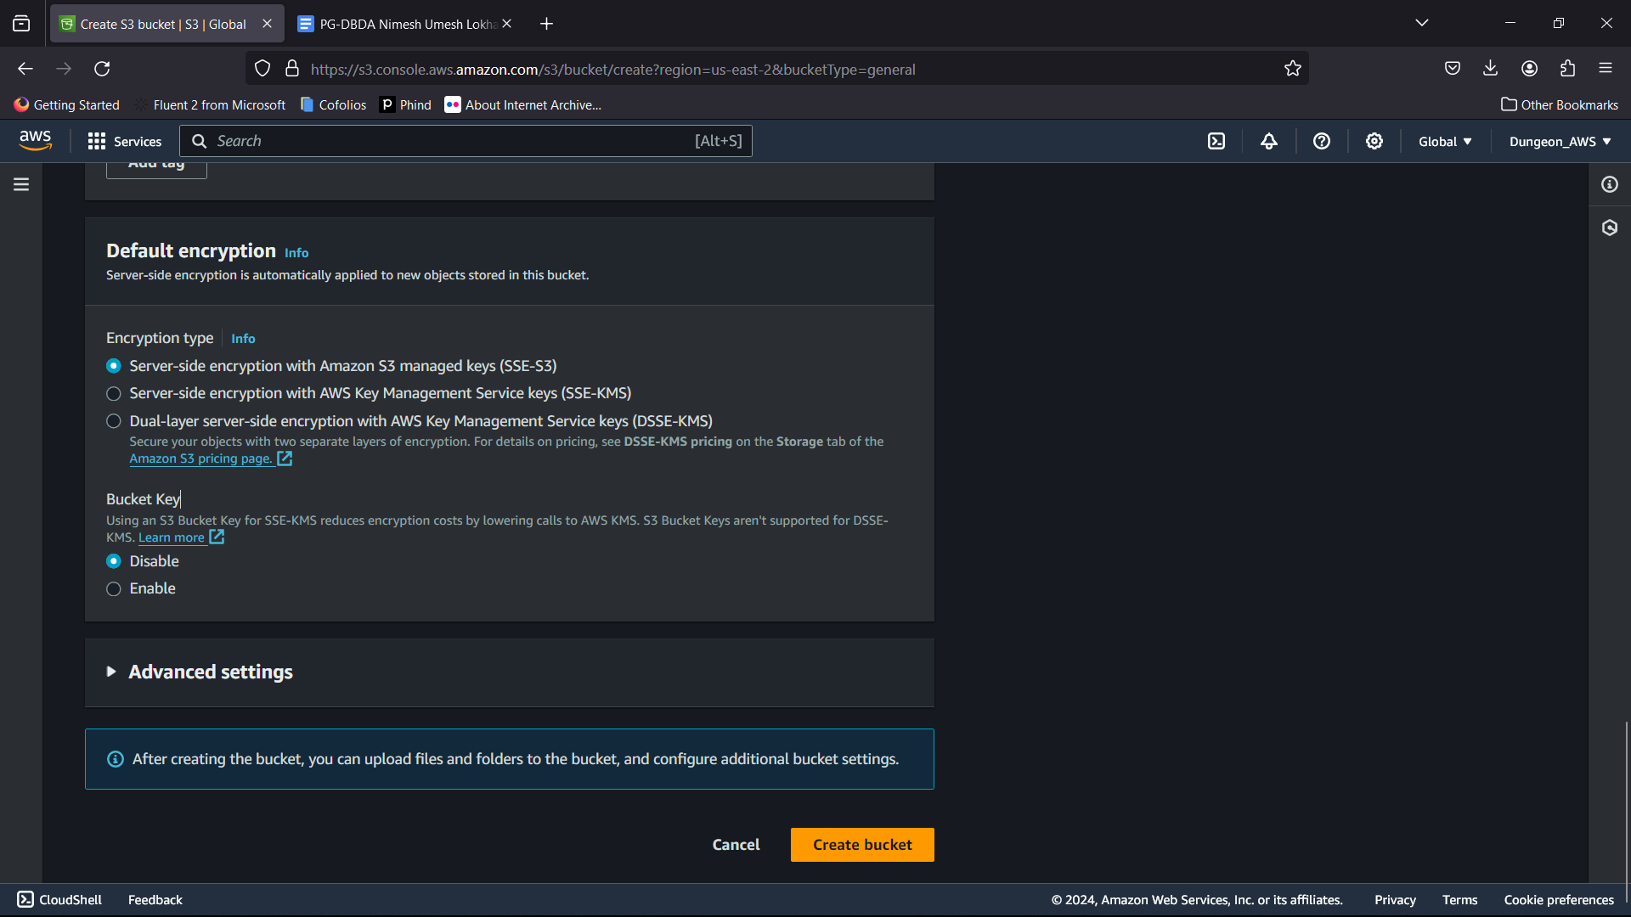

7.Click on the name of the bucket

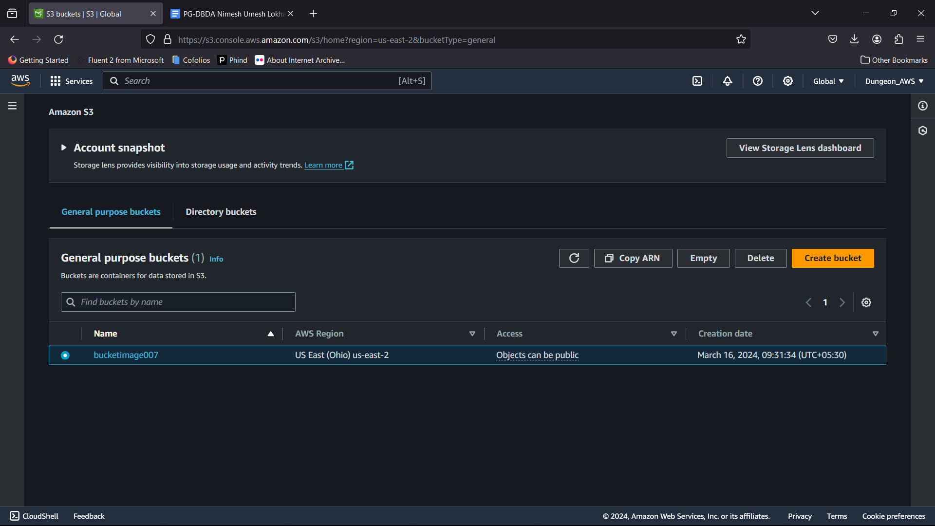

8. Click on upload

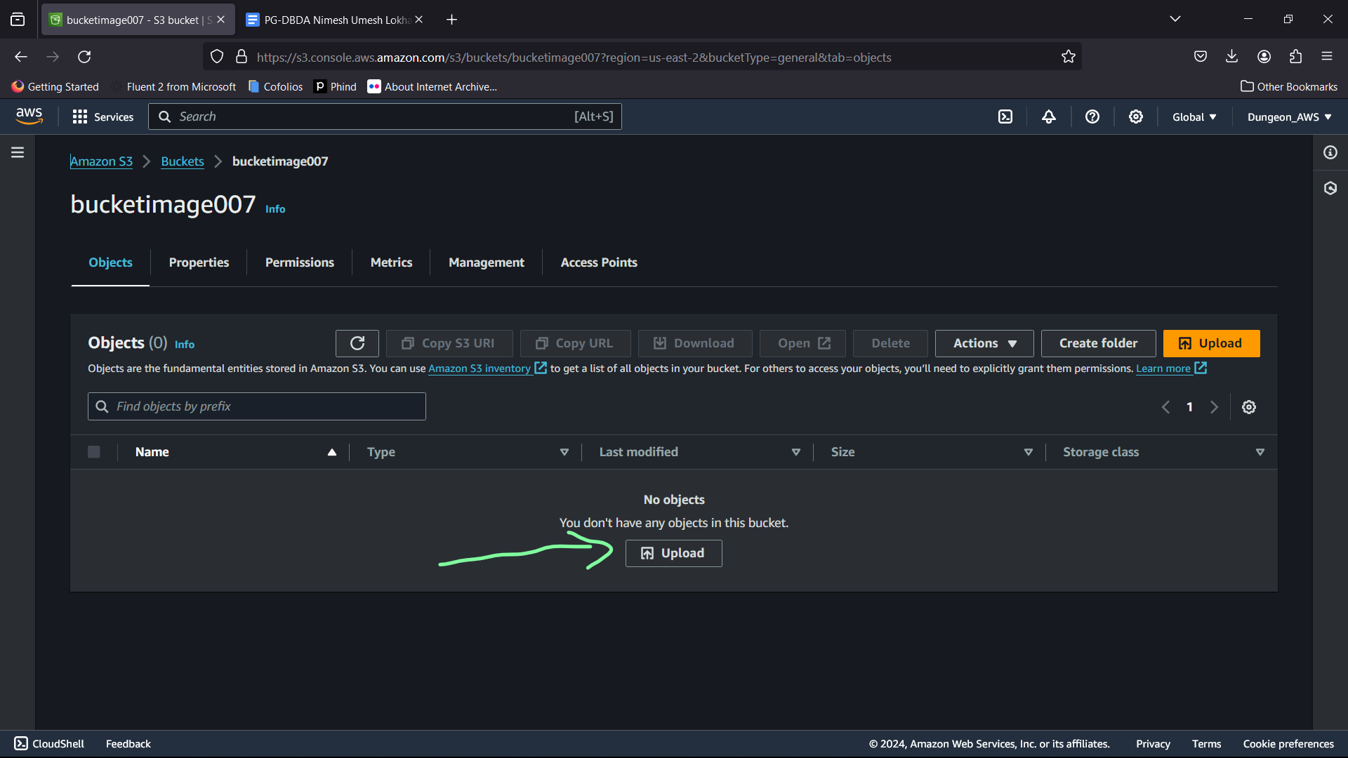

9. Click on add files and then browse until you get the file

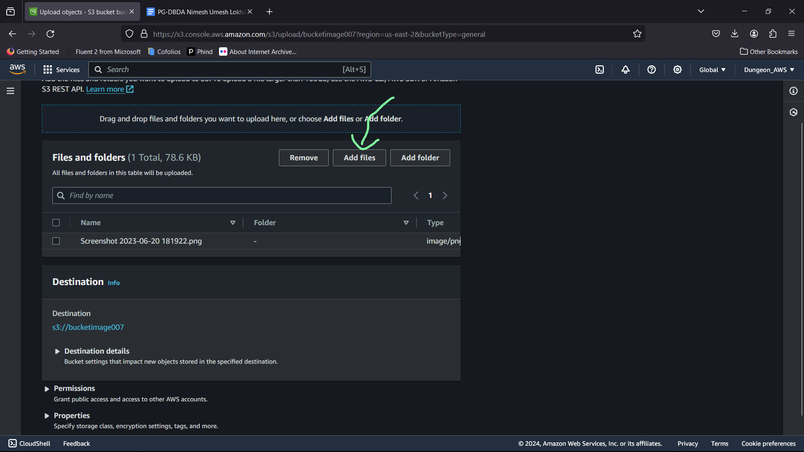

10. Click on Upload

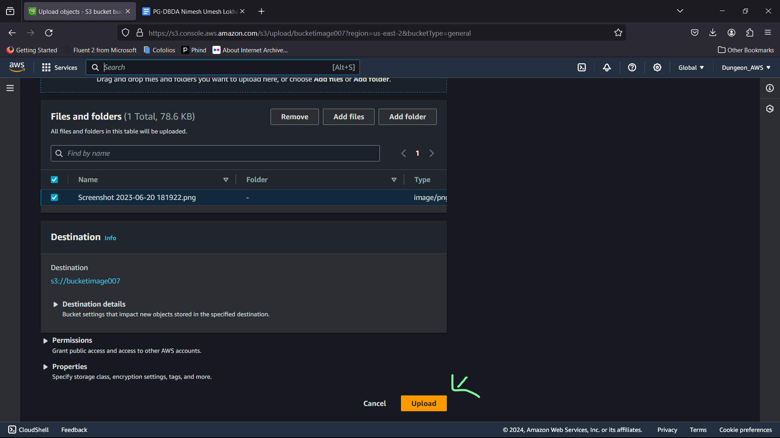

11. Once Upload, click on the destination situated in the summary tab

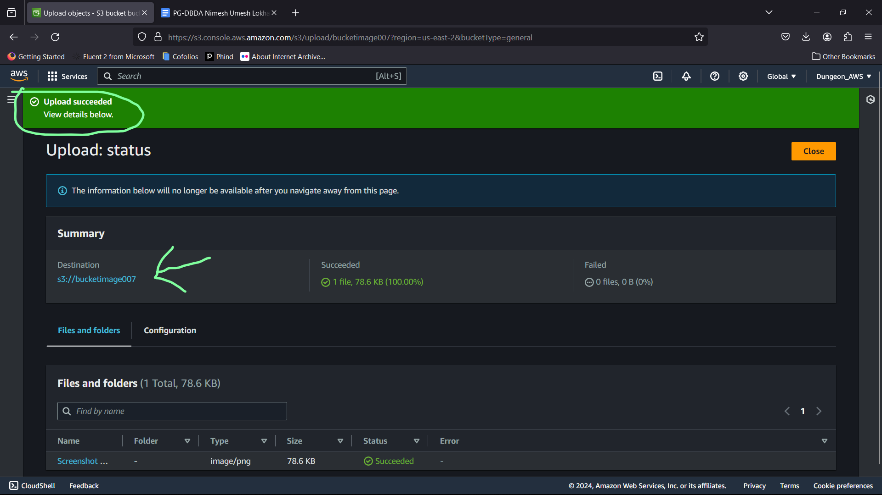

12.click on the name of the file in object format

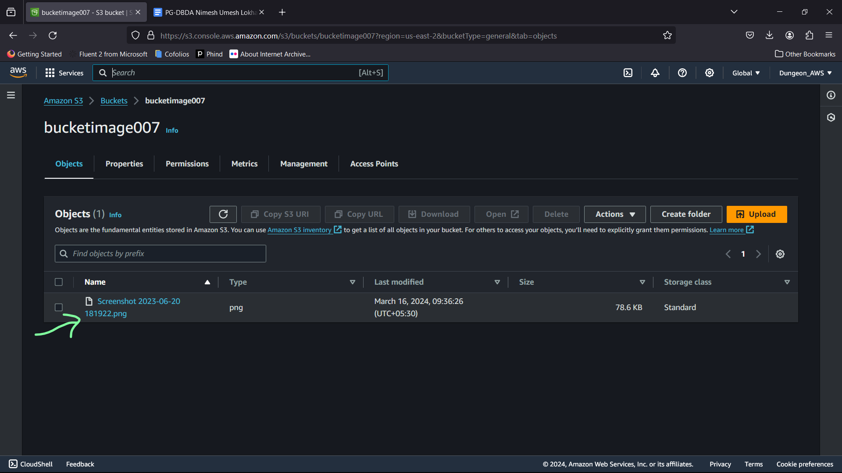

13. Go to Permission tab

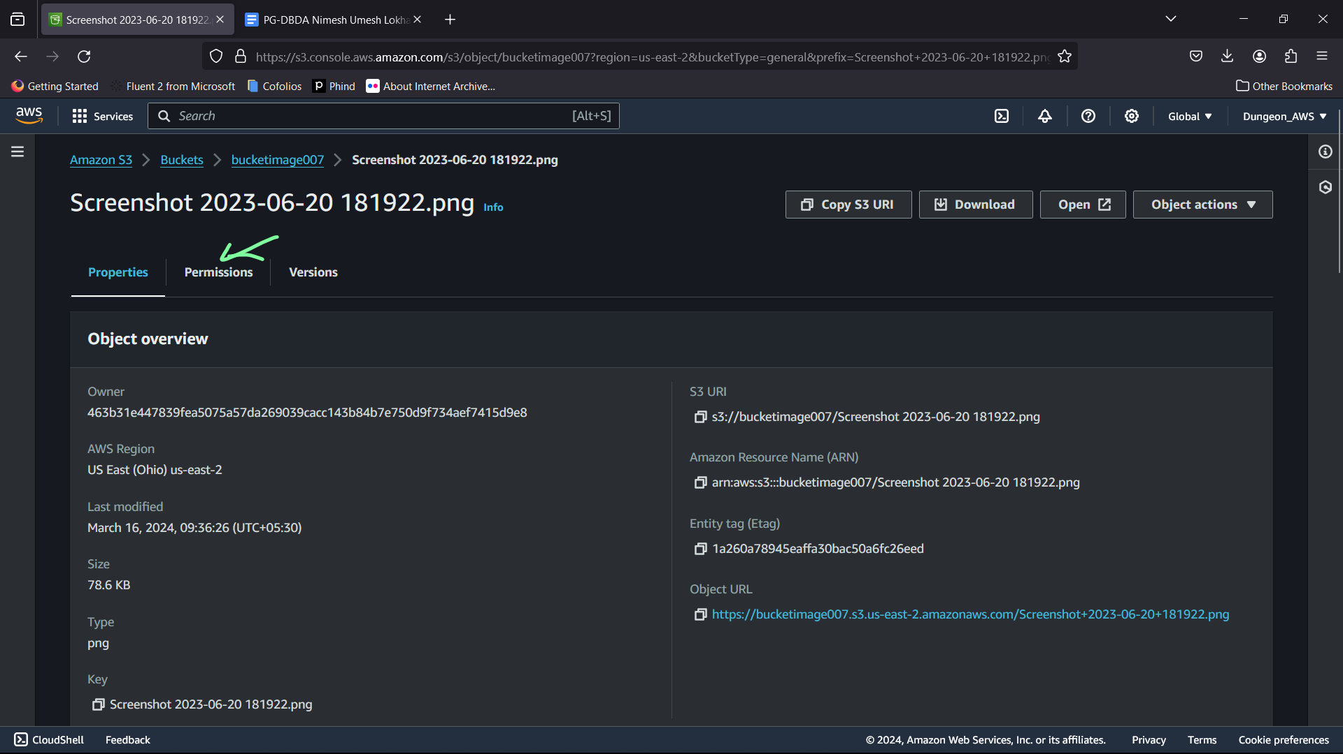

14. Click on Edit for Access Control list (ACL)

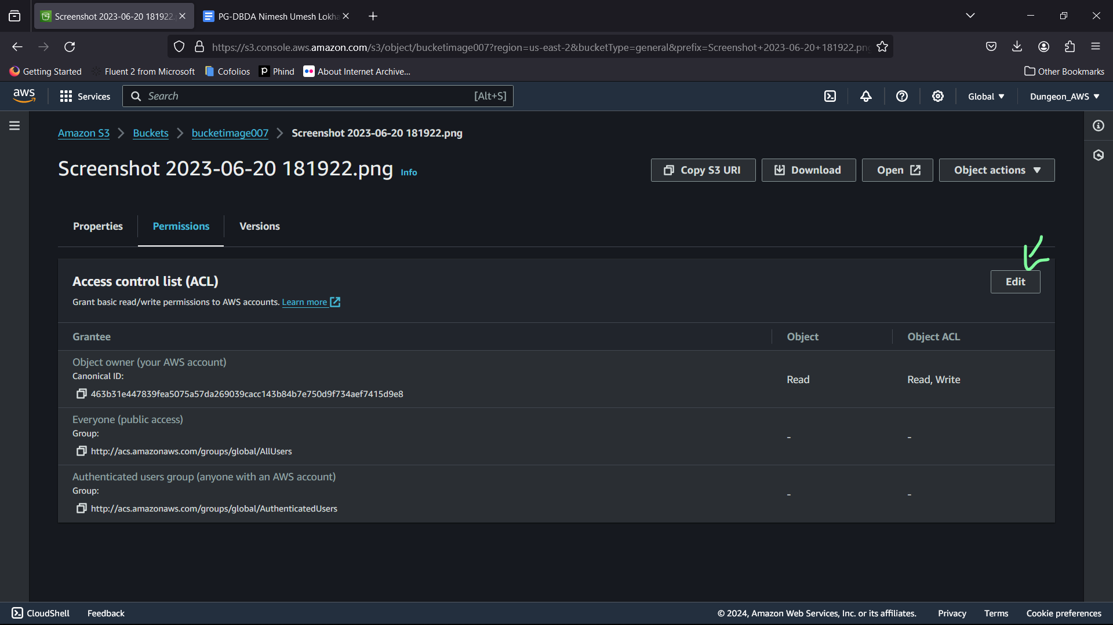

15. Click on all the designated ticks near the checkbox

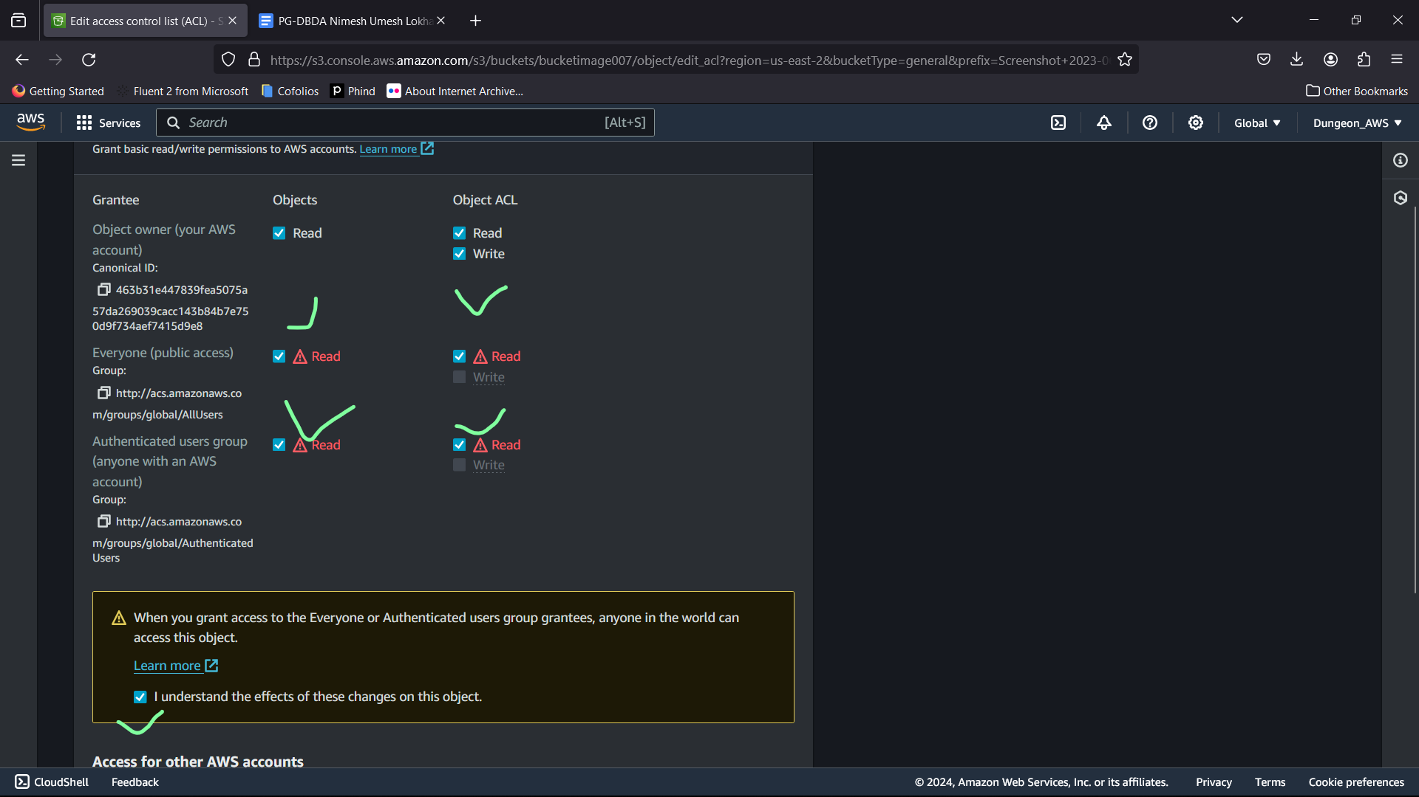

16.Click on save changes

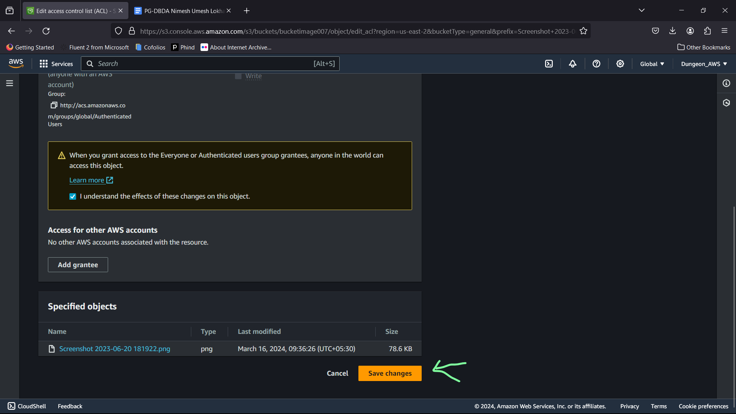

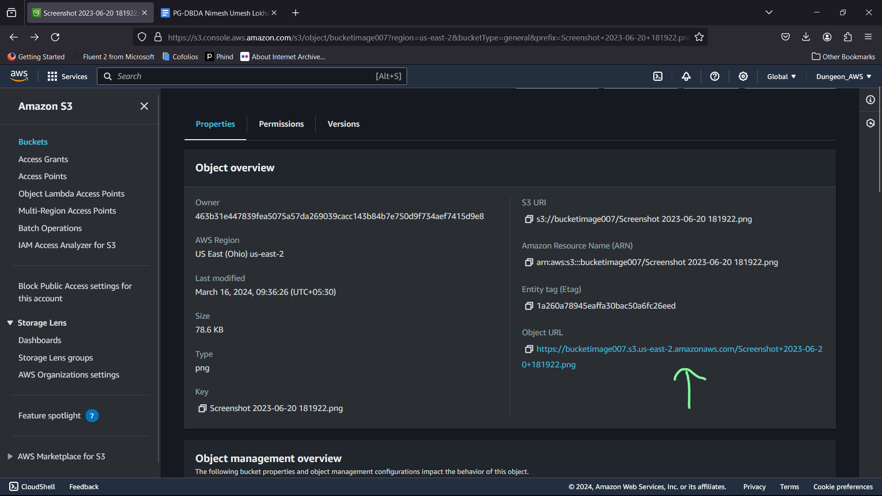

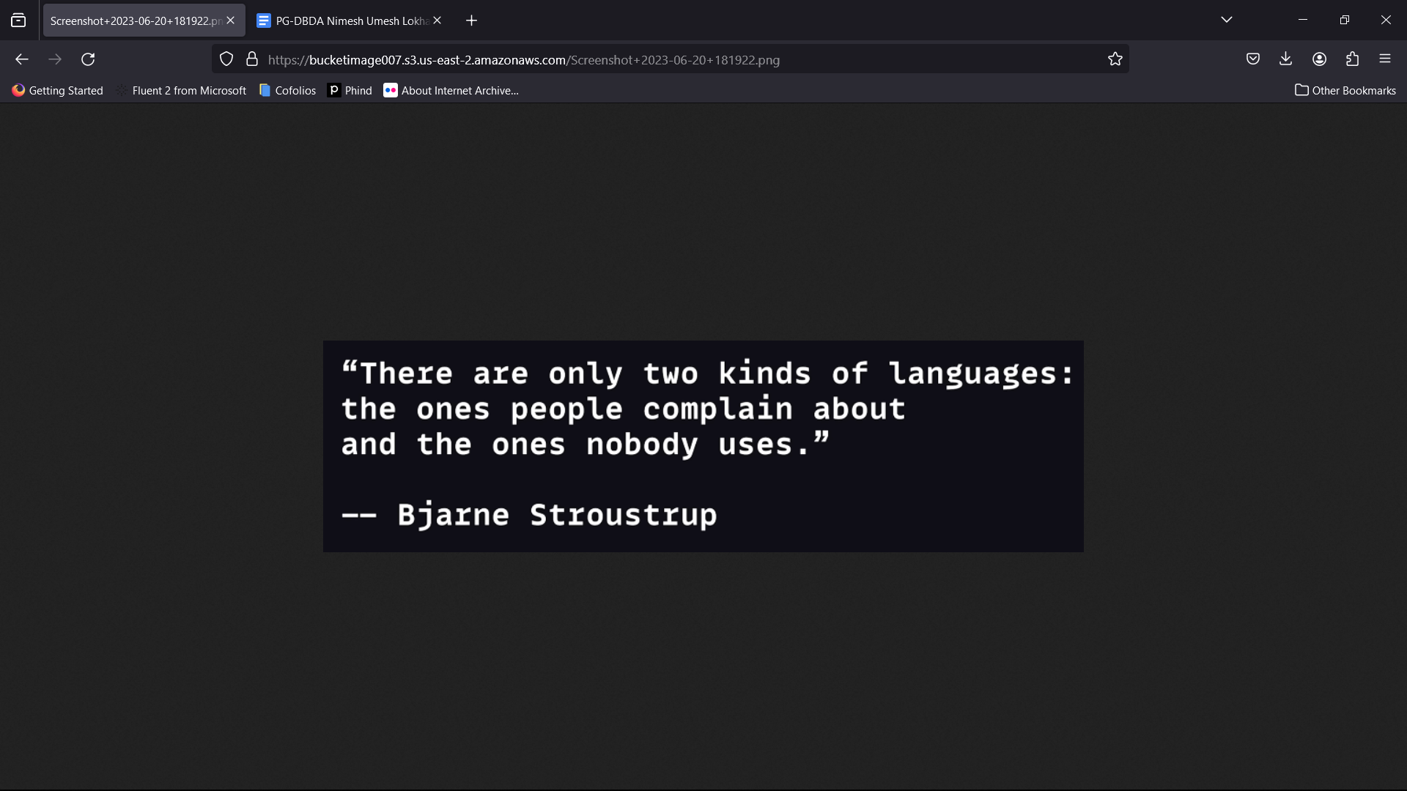

Object URL :: <https://bucketimage007.s3.us-east-2.amazonaws.com/Screenshot+2023-06-20+181922.png>